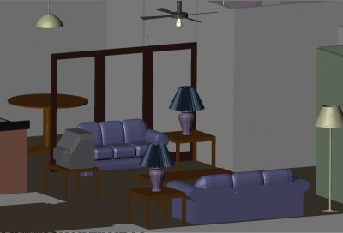
Smart Home in a Box
[Business Evaluation /Feasibility Analysis]
Authors: Vikramaditya Jakkula, & Diane Cook.
Version: 1.0.0.1
[ We thank the contribution from Gayatri on Competitor information]
[Note: Some sections need large geographical market surveys which are beyond scope during this evaluation]
[

Index

Problem Statement …………………………………………………………………………………………………………………………… 2
Proposed Solution……………………………………………………………………………………………………………………………… 2
Market Assessment…………………………………………………………………………………………………………………………… 3
Market Analysis………………………………………………………………………………………………………………………………….. 6
Competitors……………………………………………………………………………………………………………………………………… 10
Company Overview…………………………………………………………………………………………………………………………… 17
Product/Service Description……………………………………………………………………………………………………………… 19
Marketing Strategy…………………………………………………………………………………………………………………………… 22
Distribution and Sales Strategy…………………………………………………………………………………………………………. 25
Operation Plan…………………………………………………………………………………………………………………………………… 28
Management Team…………………………………………………………………………………………………………………………… 29
Financial Plan……………………………………………………………………………………………………………………………………… 30

Problem Statement

The need for smarter homes is on the horizon. People are looking towards home to be more comfortable, safer, and, luxurious. Elderly prefer homes to community living or adult care homes. The innovation in technology is slowly moving today’s home towards the future direction. Smart home technologies are answer to this riddle. However, a complete smart home technology in a box for homes/apartments is still an unexplored market domain, although smart home technology has entered the market.

Proposed Solution:

The CASAS Smart Home project is a multi-disciplinary research project at Washington State University focused on the creation of an intelligent home environment. Our approach is to view the smart home as an intelligent agent that perceives its environment through the use of sensors, and can act upon the environment through the use of actuators. The home has certain overall goals, such as minimizing the cost of maintaining the home and maximizing the comfort of its inhabitants. In order to meet these goals, the house must be able to reason about and adapt to provided information.

Link: http://ailab.wsu.edu/casas/

Short Term Goal: Conduct a pilot/feasibility study where we ship 500 units of smart home kits to various locations in US for data collection. We identify participants and select unique 500 who fit our criteria; and include them into our program of study where they receive kits, data is collected and later the kits are shipped back in whatever condition they are in.

[Related Document: Smart home in a box Pilot Program]

Market Assessment:

Target Markets
Large Warehouses + Buildings
Manufacturing/Industrial Facility

Universities
& Schools

Apartments
Commercial Office Buildings
Other buildings units

Stores, Malls & Shops

Homes

Hospitals

Smart
Home
Technology

The market domain for smart home technology is large and can be customized or applied to various markets, including but not limited to homes, apartments, hospitals, stores, malls, shops, commercial office spaces, universities, schools, industrial facilities, warehouses, and other buildings or structural spaces which are used by people or entities. For our problem we focus heavily on homes.

The Big four analysis: (The arrows indicate the money flow)

Customers: The customer space consists of primarily home owners.

- Home owners : http://www.usa.gov/Citizen/Topics/Family/Homeowners.shtml
- Assisted Living: http://www.whitmanslc.com/
- Apartments:
- Elderly homes: http://www.whitmanslc.com/
- School/College Dorms: http://about.wsu.edu/life/housing.aspx
- Homeless shelters or providers
- Refugee centers

Complimentors: The complimentors primarily consist of benefactors from this solution. People providing solutions around home would be benefited both in terms of cost and time.

- Contractors
- Tech Support :
- Sensor Suppliers: http://www.shimmer-research.com/
- Interface Development/Providers
- Computer Suppliers
- Security Systems
- Lighting Companies : http://www.insteon.net/
- Home Depot/Wiring

Suppliers: The suppliers include those who are part of the solution provision.

- Wiring providers if any: http://www.shimmer-research.com/, http://www.smarthome.com/_/index.aspx
- Sensors development : http://www.insteon.net/;http://www.shimmer-research.com/
- Software/OS : Custom made
- Deployment, supply and storage

Competitors: The competitors fall into various categories right from a complete solution providing competitor to the independent component providing competitor, any one could trigger a No-Go in market and could potentially lead the product to failure.

Solutions:
- Home automation from X10, Insteon, and more : http://www.smarthome.com/_/index.aspx
- Industrial Solution providers: Microsoft Research, GE, Bosch, Phillips and more: http://www.microsoft.com/presspass/presskits/mshome/default.aspx
- University Research Labs: Duke Smart home, and more: http://smarthome.duke.edu/

Market Analysis
The market analysis is broken down into barrier analysis and feature analysis. The market analysis is the component which needs more analysis as the survey needs to be done on a larger scale and even globally to collect data and analyze the market around (Say by countries and states).
[A] Market Barrier Analysis
Relative Merits/Barriers/Decision Criteria | Score
Available Resources | 4
Market Conditions | 3
Cost to Implement | 3
Government/Regulatory Issues | 2
Environmental Issues | 3
Economic Factors | 3
Technical Hurdles/Opportunities | 3
Competitive Issues/Threats | 2
Social/Political/Demographic Issues | 2
Adaptability | 3
Reliability/Trustworthiness | 2
Note: Score is Low to High (1-5). The higher the score the better. The lower score means we need to work on them or are potential challenges

[B] Feature Analysis:
- Product 1: Smart home in a box @ CASAS solution
- Product 2: Microsoft Research Smart Home
- Product 3: Home Automation Solution

- Market 1: Home owners.
- Market 2: Commercial or Work spaces.
- Market 3: Elderly assisted living.
Feature | Product 1 | Product 2 | Product 3
Performance | 3 | 4 | 2
Energy Efficiency | 3 | 4 | 3
Ease of Use | 3 | 3 | 3
Convenience | 3 | 4 | 2
Restocking Sensor Cost | 3 | 3 | 1
Expansion Cost | 2 | 4 | 2
Sanitation | 3 | 4 | 2
Eco-friendly | 3 | 3 | 2
Product Healthiness | 3 | 3 | 2
Maintenance | 3 | 2 | 4
Security | 3 | 3 | 3
Home Automation | 4 | 4 | 4
Pet Care | 2 | 3 | 0
Audio/Video | 3 | 3 | 3
Wired/Wireless | 3 | 4 | 3
Household Management | 3 | 4 | 1
HealthCare | 3 | 4 | 0
Privacy | 3 | 3 | 0
User friendly Software/UI | 3 | 5 | 0
Appliance Friendly | 3 | 3 | 0
Ease of Installation | 3 | 3 | 1
Convenience | 3 | 4 | 2
Training | 3 | 3 | 0
Availability/Varity of Sensors/Technology | 3 | 3 | 0
Life cycle cost(= Installed cost + mainataince cost ) (show it depreciates over time) | 3 | 4 | 0
Proprietary/Open architecture | 4 | 2 | 0
Tech Support | 3 | 3 | 0
Feature | Market A | Market B | Market C
Performance | 3 | 2 | 5
Energy Efficiency | 5 | 5 | 5
Ease of Use | 3 | 2 | 5
Convenience | 3 | 3 | 5
Restocking Sensor Cost | 3 | 4 | 3
Expansion Cost | 3 | 4 | 3
Sanitation | 3 | 3 | 5
Eco-friendly | 3 | 3 | 3
Product Healthiness | 3 | 3 | 3
Maintenance | 3 | 2 | 5
Security | 3 | 3 | 5
Home Automation | 3 | 3 | 5
Pet Care | 3 | 1 | 1
Audio/Video | 3 | 3 | 3
Wired/Wireless | 3 | 3 | 3
Household Management | 3 | 2 | 4
HealthCare | 3 | 2 | 5
Privacy | 3 | 3 | 3
User friendly Software/UI | 3 | 2 | 4
Appliance Friendly | 3 | 2 | 4
Ease of Installation | 3 | 2 | 3
Convenience | 4 | 3 | 4
Training | 3 | 3 | 4
Availability/Varity of Sensors/Technology | 3 | 3 | 3
Life cycle cost(= Installed cost + mainataince cost ) (show it depreciates over time) | 3 | 3 | 3
Proprietary/Open architecture | 3 | 3 | 3
Tech Support | 3 | 3 | 3
 | Market A | Market B | Market C
Product 1 | 1.86 | 1.33 | 2.36
Product 2 | 2.33 | 2.06 | 2.52
Product 3 | 1.03 | 0.9 | 1.11

Our current solution looks very feasible for Elderly or Assisted living setting. Also note that the scoring was done based on the document author and no survey was conducted. A proper large scale geographically spread survey would enhance the quality of the survey and the solution offering.

Competitors

There are many competitors in the market and many more in the pipeline including university based start-ups. The competitors are targeting multiple domains or market segments, here we focus on just two domains that of elderly care and smart home as a whole.

[1] GE Quiet care: 5 activity sensors + small sub-station within the home
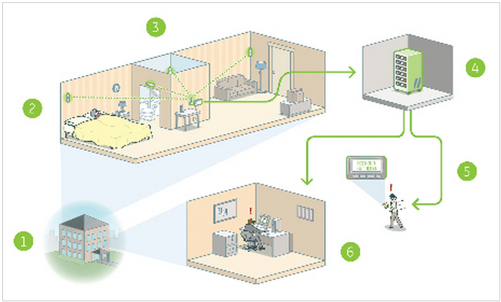
PRODUCT(S) | COST | MARKET SEGEMENT | MARKET SIZE
Senior community:  learns daily living patterns through wireless motion sensors and alerts sent to pagers or cell phones or email or text message or fax  helps in early detection of health problems  sensors placed @ doors, bedrooms, bathrooms, adjacent to medications and refrigerators  Privacy maintained (no camera, no microphones)  Reports temperature extremes (http://www.gehealthcare.com/usen/telehealth/quietcare/docs/Telehealth_SuccessStoryMulberryGardens.pdf)  Useful in memory care units (dementia)  Detects risk of falls, UTI  Have local clinical team to provide support | Available in three packages (http://www.totalhomesecurity.com/quiet-care/)  Silver: for personal caregiver of family member – 24/7 early detection and warning - installation & activation cost $149 and base price $59.95/month  Gold: For third party monitoring – 24/7 early detection and warning - AARP endorse LifeFone PERS $79.95/month  Diamond: LifeFone monitoring - 24/7 early detection and warning & full-service PERS - $89.95 | Assisted living & individual homes
Seniors and Families:
Wireless motion sensors in their own place and alerts staff with any changes in the pattern

[2] Grand Care Systems: Launched in 2006. System includes TiVo box (central unit) connected to TV/monitor with either wired/wireless internet. Messages, email, reminders are sent to customize TV channel by the family.
Not a PERS system: Easy installation – dealers perform care assessment and installation (http://grandcare.wordpress.com/2010/08/28/grandcare-systems-high-tech-caregiving/)
Can purchase or lease the system used by patients with chronic disease too

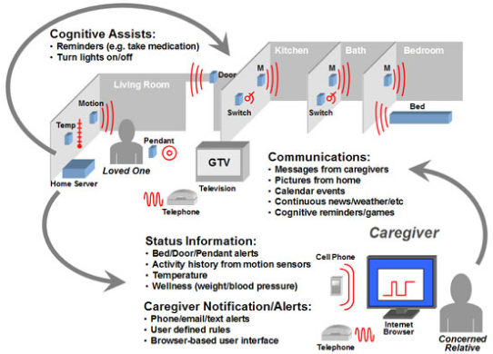

PRODUCT(S) | COST | MARKET SEGEMENT | MARKET SIZE
For private home:  Wireless sensors monitors activities of daily living, temperature, checks weight and blood pressure  System alerts through email, text message or phone to remote family or professional caregiver  Provides independent living and freedom | less than money paid for 30 days in assisted living facility.  Leasing rate $300-$500 upfront cost and $99-$299/month.  $15-$25/day (http://grandcare.wordpress.com/2010/08/28/grandcare-systems-high-tech-caregiving/) or  Between $3000-$8000 + $49/month for monitoring service(http://grandcare.wordpress.com/tag/aging-in-place/) | For private home & community care providers
For providers
Trillium Kiosk:
Located centrally for social gathering
Wellness readings can be taken by multiple residents
Trillibit
Notebook – portable & hand-held for residents, assisted living facilitators or professional caregivers
Wireless wellness readings
Multiple Resident Como system
System is common for a series of resident rooms, installed in the hallway
Sensor devices to individual rooms
[3] Microsoft Smart Home
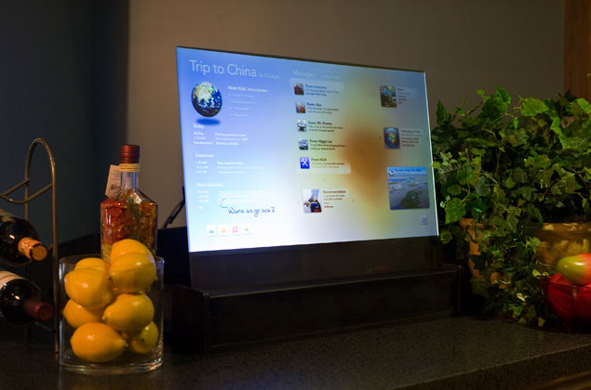
Figure 1. Smart home living room interface (Credit: Microsoft Research)
This is the true competitor for the proposed smart home solutions, where they make home truly automated and personalized. They not only make the home a better place to live but they offer user personalization and better technology solution for home making it smarter. This solution offers more features than the solution/competitor below by using advanced technology such as machine learning based solutions and offering wider range of services.
Links:
- http://www.microsoft.com/presspass/presskits/mshome/default.aspx
- http://www.youtube.com/watch?v=ODpReoKQVXM

[4] SmartSolutions
SmartSolutions provide smart home solutions which primarily focus on home automation. They provide technology based solution to automate home environment. They provide consumer benefit via making home easier to live,safer, and more comfortable but do not offer advanced home automation such as user personalization and more. The solution they provide stands as a baseline for home automation and are cost friendly. The solution they offer basic home automation but better than a normal home including automation, improved luxieries like audio video entertainment system, smart kitchen, and so forth.
Link: http://www.smarthomesolutions.com/automate.html

Company Overview

Name of our company: CASAS LLC. (The company needs to be formed.)

Company organized: To begin with the company will be a limited liability company, and later expand into a Corporation as it grows over the years based on the venture revenue raised.

Overall Strategy:

The strategy can be to improve convenience in living at homes, by offering home automation using advanced technology solutions, with a vision of complete user comfort for a happier living, and adding value of comfort, safety, luxury and improved lifestyle at home.

Other Strategies: (To enter other market segments when expanding)

Strategy 1: Enabling students to live active lifestyle at school via a smart dorm solution. The vision would comprise of enabling students to realize their potential and become achievers via improved lifestyle. The value brought in includes convenience, experiences, and improved lifestyle @ school.
Strategy 2: Enabling elderly and older people to live healthier and happier at home. The vision comprises of smart home technology providing smart medication technology which would help older adults stay longer in home. The value brought in includes better & healthier life, assisted lifestyle with technology based solution with lower cost.

Objectives: Offer smart home technology solution for everyday usage by home owners.

Goals: Offer smart home technology solution which:
  - Makes living at home easier.
  - Make living at home safer.
  - Make living at home luxurious.

Mission: Improve convenience in living at homes, by offering home automation using advanced technology solutions

Vision: Complete user comfort for a happier living, and adding value of comfort, safety, luxury and improved lifestyle at home.

Value Statement: Improved Lifestyle, Comfort living, improved health care, technology solution for easier living, enhanced security, and luxurious life.

Product/Service Description

Solution A: The solution A takes a wired approach.
Sensor | Usage | Cost | Manufacturer
Motion Sensor + Custom Board | 12-24 (Location size) | 15$ + $4(board Cost) | Vision-Tek + Add-in Board (In-house)
Temperature | “” | 4$ + (Same board above) | In-House
Door Sensor | Location/Doors/Cabinets | 4$ | In-House
Power Meter | 1 | $200 | Energy Inc
Wiring | Location | 10 Cents per foot | Local store
USB Bus Helper | 1 per location | $20 per piece | Drill semi-conductor
Sheeva Plug | 1 per location | $100 per piece | Global Scale Technologies
Touch Screen | 1 per location | $300 per PC | Asus PC – EETOP

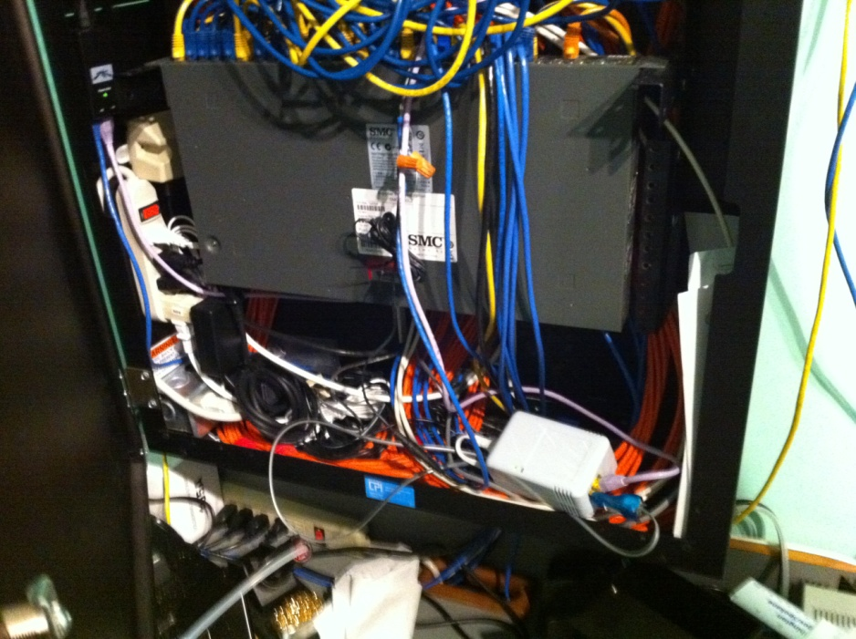
Figure 2. Sheeva Plug with data cables

Solution B: The solution B explores a wireless solution.
Sensor | Usage | Cost | Manufacturer
Wireless Base Station | 1-2 location | Market Price: $600  Our Cost: $300 | Control 4
Motion Sensor | Based on Location | Market Price: $150  Our Cost: $75 | Control 4
Battery | Based on sensor
Motion Door Sensor | Door/Cabinet | MC: $150  Our Cost:: $75 | Control 4
Lightening Sensor | Location | MC:$130  Our Cost: $60 | Control 4
Touch Screen | 1 per location | $300 per PC | Asus PC – EETOP
Power Meter | 1 | $200 | Energy Inc
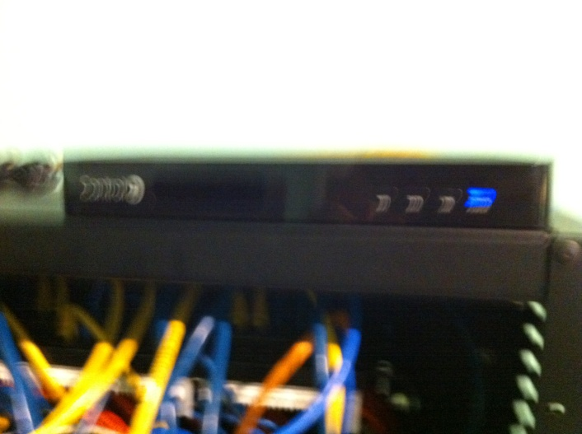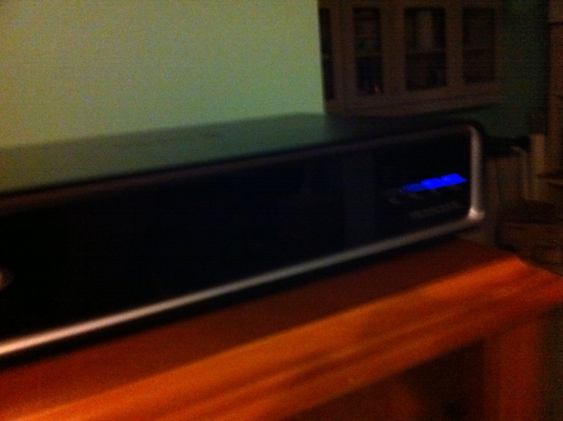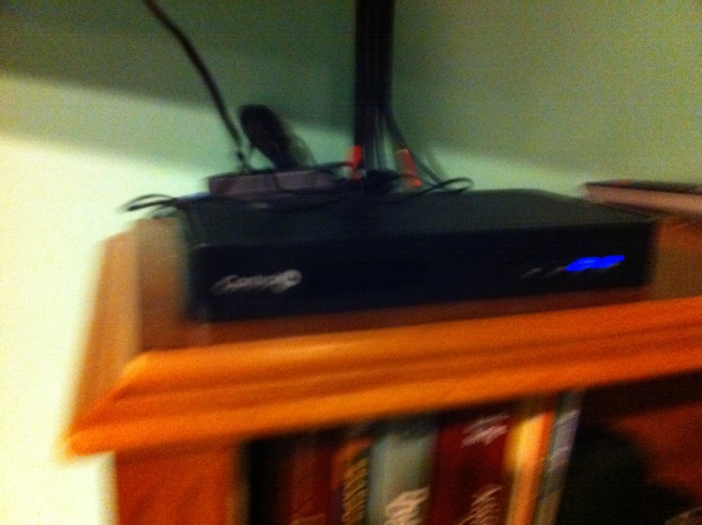
Figure 2. Control 4 wireless sensors
Trade-off:
Solution A | Solution B
High Labor cost  High maintenance  Low/economic overall cost  Low devices cost for replacements  Scalability is expensive or increases cost | Low labor cost  Low mainataince as wireless  High Overall Cost  High device cost for replacement  Easily scalable to newer rooms/locations in home.

Proprietary rights to the product/service: Software solution offered is proprietary and would be patented and copyrighted. The hardware sensor technology will be copyrighted by their respective owners.

Marketing Strategy

Target customers:

- Home Owners (Primary)
- Apartment Residents
- Living spaces/Units
- Any Living environment (Lab spaces and animal shelters too).
- Assisted living spaces

What motivates the buying decisions:

- Offer simple setup
Home users are do not want to spend their time installing smart home kits/solution. Not only do they require extensive renovation and wiring skills that most home users do not have, they also require a familiarity with technology that is uncommon in most home owners. Hence providing a simple solution would be ideal with easy setup and technical assistance via phone support.
- Simple To Use
Home users worry that smart homes will out smart them and have unpredictable actions, this adds stress to the user. Offering a solution which is simple to use and learns preferences/user behavior over time.
- Need minimum change in home environment
Most homeowners do not renovate their homes frequently thereby eliminating the chance for home control systems to enter their households. We need a smart home that is plug & Paste. If we have a system that is installable just via a wall socket, many more home owners will be receptive to the idea of smart home systems. This is a unique selling point for our solution offering.
- Targeted at middle class mass market heavily
The Market is currently targeted at high end homes where users are willing to pay a premium for a smart home system when they renovate their homes. Middle class homes are not being targeted as they are unwilling to pay the price for a smart home system. So targeting both these segments would help the product success over long period of time.
- Too much technology can be a bad thing
User education about technology offering and why our technology solution is minimum yet offering maximum benefit is important.
- Reduce Over Concern regarding system failure
Because the exposure to smart home systems are so low, it is expected that many people are concerned over the failure of these systems. Building trust worthiness is key.
- Avoid obvious NO-use scenario
Smart homes provide many features that are sure to bring convenience/comfort and enable to live well. But as a package, there is no one clear benefit that is a killer feature. For platform products to succeed there must be a killer feature. Identify the killer feature against market competitors would help the product to succeed.

SWOT Analysis
Strength:
- Skilled workforce with propriety software technology and leveraging external hardware technology: The skill workforce is available or can be easily trained as needed. The existing technology and the room for new technology integration is easy.
- Unique and tested solution offering: The solution offered is pretested in multiple test beds and is a unique solution offering.
- Increased comfort with economic pricing: The pricing for the entire solution and the life cycle cost is lesser than the competition. The mainataince cost is varied, but still is economic in nature.
- Latest sensor technology
- Excellent availability by making it available for mass market
- Little/non-threatening competition with the price offering in market domain.

Weakness:
- Company name not recognized on a National/Regional/Local level: The brand recognition is required or needed.
- Manufacturing process pipeline: The efficiency of the production pipeline needs working and improvement.
- Rented premises (Adding to costs): Building, testing and storage needed.
- Poor location for business needs (Lack of transport links etc)
- Stock problems (currently holding too much/too little)
- User acceptance and skill level.

Opportunities:
- Skilled workforce: The workforce can be moved and trained into other areas of the business
- Competitor going bankrupt: Takeover opportunity and also partnering opportunities.
- Upgrade technology: New technology can be installed with ease.
- Increased spending power in the Local/National economy
- Moving a product into a new market sector

Threat:
- Large and increasing competition: Increase in competition, new players in the market.
- Local authority/Governing bodies regulation issues: Getting approvals and permissions and certifications needed.
- Rising cost of Wages (Basic wage, etc): The need for change of costs over time. New technology could potentially have high costs. Increased sales could lead to the increase in potential maintenance costs or support provision costs for the company.
- Possible relocation costs due to poor location:
- Existing product becoming unfashionable or unpopular

Product Price

The pricing will be broken down by layers/offering:

A] Base price - Includes a base station, minimum sensors (8-12) and other components with basic technical support
B] Premium Package - Includes 3 base station, sensors (16-24) and other components with Premium technical support
C] Expansion pack – Includes a base station, and minimum sensors (8-12) [Purpose of expansion pack are to expand to new rooms or renovation/other scenarios]
D] Independent sensor purchase option for existing customers.
E] Room based solutions offering – Room or layout based solution, planning and assistance options.
F] Installation Option – Local certified Installation Providers
G] Additional technical support – Can be pay per call model.

These pricing details will be calculated after negotiations with the partners who supply hardware and our software evaluation and pricing.

Anticipated annual sales (units sold times price per unit): <Needs market survey>

Distribution & Sales Strategy

Distribution channels:

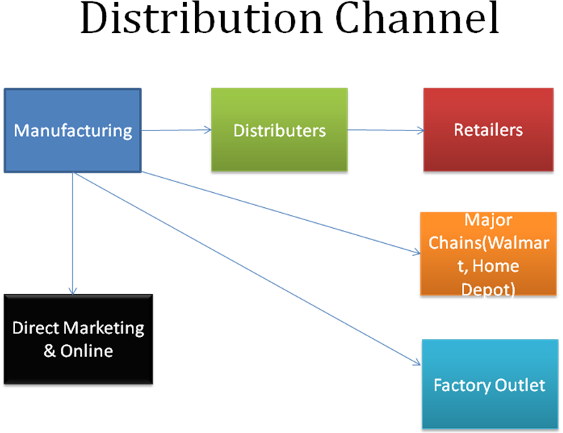

Manufacturing: Finding & setting up a manufacturing and testing facility which also acts as storage unit till large scale expansion.
Distributors: Find local and national distributors.
Retailers: Construct a retailers program to encourage sales.
Major Chains: Home depot, Wal-Mart, more.
Direct Marketing: Amazon.com, Ebay.com, Online store, and other opportunities.

Communicate with our customers (e.g., advertising, promotions, etc.):

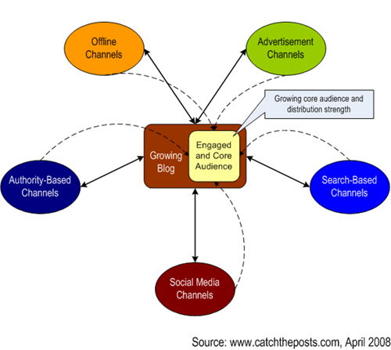

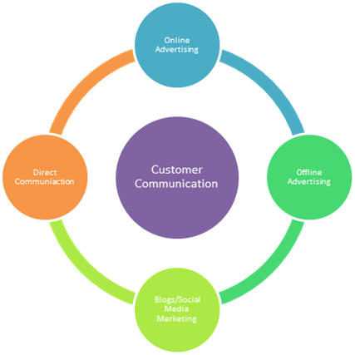

Sales strategy:

- Your target customers: Business growth depends on creating new, profitable business with different customer types.
- Sales planning: A Together with your sales employees, prepare your sales forecast.
- Measuring performance: A Conduct an annual or quarterly profitability analysis.
- The framework takes the classic idea of the three C’s (Costs, Competitors, Customers) to sales force execution.
- For the first few years it’s all about building the brand.

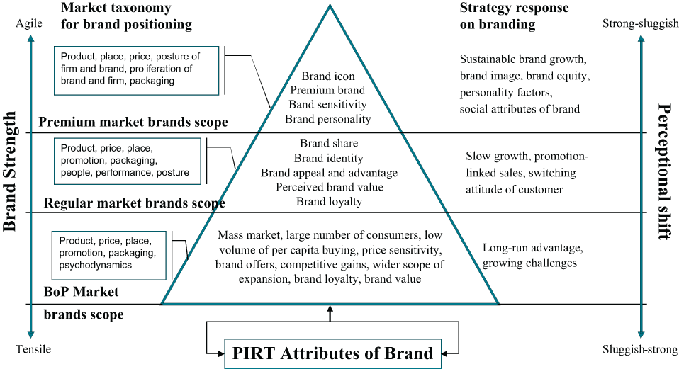
Brand Value [Credit: Measuring Business Excellence http://www.emeraldinsight.com]

Operations Plan

- Which operations are critical to the success of our business?

Priority Process or Critical Process:
- Production or manufacturing: Getting the smart home in a box kits in place and tested.
- Facilities: Have both resource and man power facility. Resources include right from production houses to storage units.
- Inventory: The rightly projected inventory.
- Distribution: Distribution pipeline and timelines are very critical to have the right market impact.
- Maintenance and service - Order fulfillment and customer service: Post sales process.

- How will we produce and deliver our product/service? What will we do in-house, and what will we purchase (make vs. buy)?

Production Pipeline in the Initial stages:
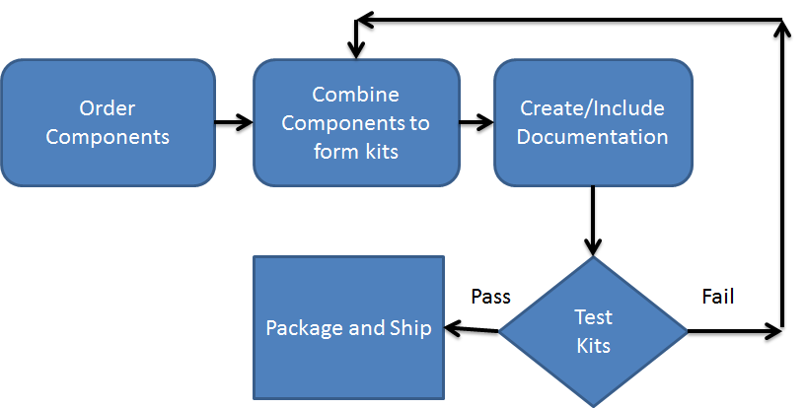

- What will it cost to produce and deliver our product or service? Estimate fixed costs (plant, equipment, etc.) and variable costs (labor, materials, etc.)

This will depend on the scale we plan to start. If small scale for a year, we would want the cost to be small to test and later invest heavily in large scale production facility.

Management Team

Stakeholders | Diane Cook and Larry Holder.
Program Management | <Should Hire>
Software Development | <Should Hire>
Finance Management | <Should Hire>
Marketing & Sales Management | <Should Hire>
Legal and Patent Management | <Should Hire>
Data management | <Should Hire>
Technical Support | <Should Hire>
System Administration | Jim Kuznier
Post-Docs | Aaron Crandall, Chaitanya Narayanan Krishnan and Parisa Rashidi.
Students | Vikramaditya Jakkula, Jack Chen, Barnan Das, Prafulla Dwawadi and more as enrolled.

Financial Plan

This needs a proper market survey. This will be finished only after gathering survey input.
<This section needs to be finished after a large user survey is performed where we have a true market understanding.>

Summarize estimates made in previous sections:$
A. Annual unit sales:
B. Price per unit:
C. Variable cost per unit (production and sales):
D. Fixed costs (admin, production, and sales):
E. One-time start-up costs (eqpmt, mktg, legal, etc.):
F. Working capital rqd (receivables , inventory, etc.):

Calculate estimated annual gross revenues and income:
G. Estimated annual revenues (A*B):
H. Estimated annual variable costs (A*C):
I. Estimated annual contribution margin (G-H-D):

Calculate break-even figures:
J. Contribution margin per unit (B-C):
K. Annual break-even quantity (D/J):
L. Ratio of break-even to expected quantities (K/A):

Estimate the money you will initially need to start your business:
M. Total up-front funds required (E+F):
N. Additional units to cover up-front funds (M/J):
O. Break-even quantity with up-front funds (K+N):

Calculate financial performance figures:
P. Payback period for startup funds (M/I):
Q. Annual return on start-up investment (I/M):
R. Variable cost to price ratio (C/B):
S. Contribution margin ratio (I/G):

Sources of cash:

Initial stages: Research grant/ University Grant.
Based on progress/profit: Venture Capital or An angel

Projected Revenue:

Note: Needs market/user survey.

 | Year 1 | Year 2 | Year 3
Sales
Expenses
Operating Profit

Exit Strategy: <Based on source of cash>

